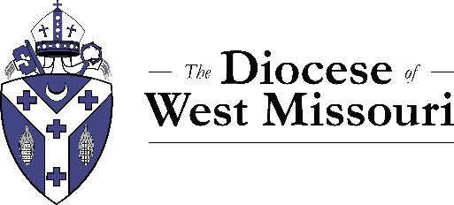

The Rt. Rev. Amy Dafler Meaux
The Diocese of West Missouri
420 W 14th St.
Kansas City, MO 64105

Dear Bishop Meaux,
In accordance with the Canons of the Episcopal Church, I hereby apply to be admitted as a Candidate for ordination to the . I was admitted as a Postulant on .
Yours in Christ,

_______________________

