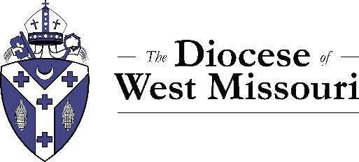

The Rt. Rev. Amy Dafler Meaux
The Diocese of West Missouri
420 W 14th St.
Kansas City, MO 64105

Dear Bishop Meaux,
Episcopal Church, , Missouri, reaffirms its support for as applies to be admitted as a Candidate for ordination to the . We continue to believe that possesses the gifts required for ministry as a and that God is now calling to now to exercise ministry within the order of . We continue to pledge to contribute financially and to involve ourselves in preparation for ordination.
Attesting to this letter are , , and at least two-thirds of the made up of members.

Yours in Christ,

_______________________________ ______________________________

_______________________________ ______________________________

_______________________________ ______________________________

_______________________________ ______________________________

