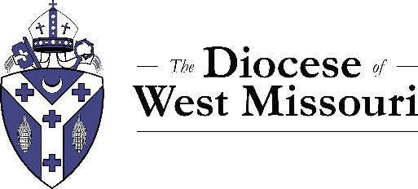
Date

The Rt. Rev. Amy Dafler Meaux
Diocese of West Missouri
420 W 14th St.
Kansas City, MO 64105

Dear Bishop Meaux,
I accept (name of church)’s nomination to ordained ministry and hereby apply for admission as a Postulant for . are the Nominee Information Form, a recent photograph, my resumé, college & graduate transcripts, evidence of baptism and evidence of confirmation or reception in The Episcopal Church.
Insert here a description of the process of discernment by which you have been identified for ordination.

Sincerely,

(name)

