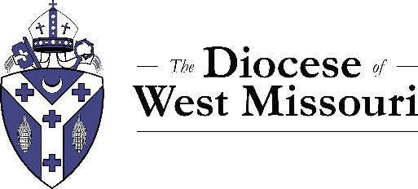

Date

To: The Rt. Rev. Amy Dafler Meaux
Diocese of West Missouri
420 W 14th St.
Kansas City, MO 64105

From: Name
Church
Street address
City, state, zip

Dear Bishop Meaux,

Name of church Episcopal Church, City, Missouri, reaffirms its support for ordinand's full name as applies for ordination to the . We continue to believe that ordinand's name possesses the gifts required for ministry as a priest/deacon and that God is now calling to exercise ministry within the order of . We continue to pledge to contribute financially and to involve ourselves in ordinand's name’s preparation for ordination.

Attesting to this letter are Rector/Warden's Name, , and at least two-thirds of the made up of number members.

Yours in Christ,

